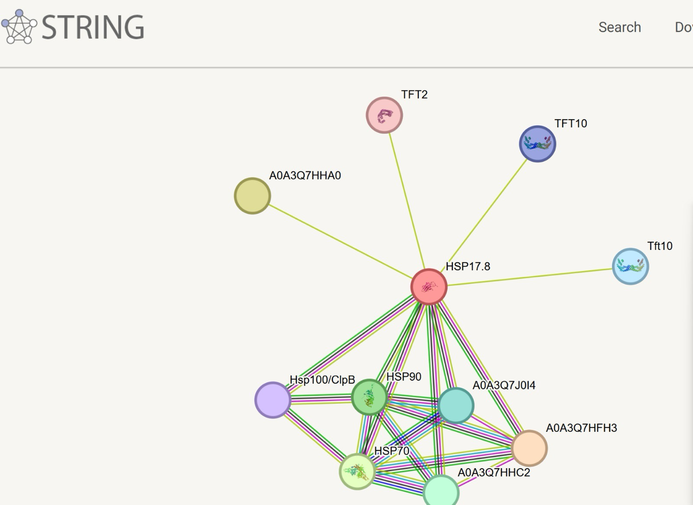
6.⁠ ⁠Protein–Protein Interaction Analysis

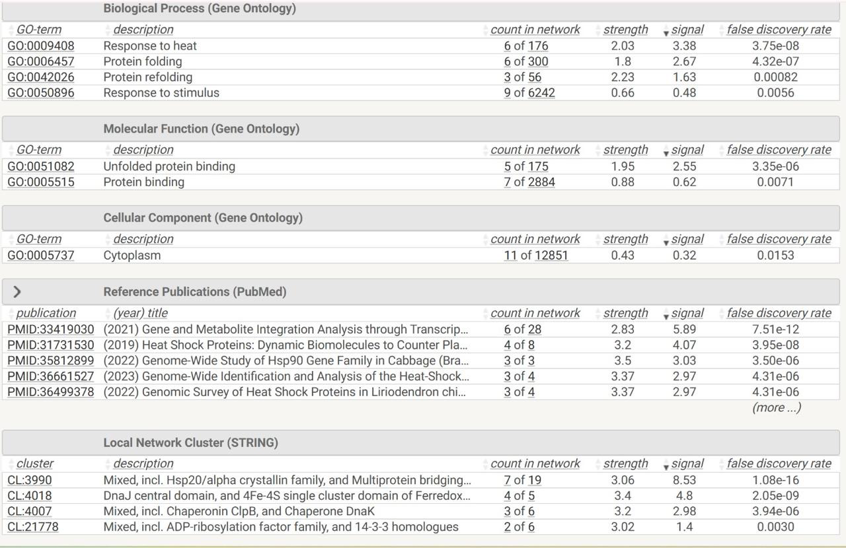

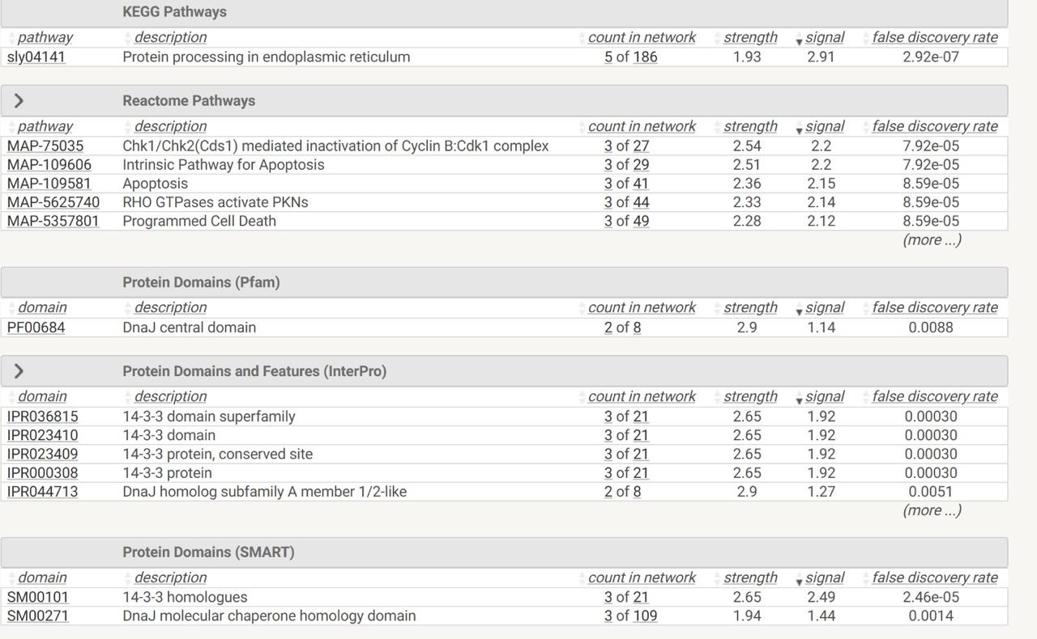

Protein–Protein Interaction (PPI) Network (STRING)

What it shows
HSP17.8 is the central (hub) protein, strongly connected to HSP70, HSP90, HSP100/ClpB, DnaJ (Hsp40) and other stress-related proteins.
These interactions are supported by multiple evidence types (colored edges): co-expression, experiments, databases, and text mining.

Biological significance

This indicates that HSP17.8 functions as a molecular chaperone, working together with major heat-shock proteins.
Such networks are typical of proteins involved in:

1.Protein folding
Prevention of protein aggregation
Recovery from heat and cellular stress
The hub position suggests HSP17.8 plays a coordinating role in the cellular stress response.

2. KEGG Pathway Enrichment
Key pathway identified
Protein processing in the Endoplasmic Reticulum (ER)
ER protein processing is crucial for:
Proper folding of newly synthesized proteins
Handling of misfolded or unfolded proteins
Enrichment here confirms that this protein
participates in proteostasis (protein quality control), especially under stress conditions.

3. Reactome Pathway Enrichment
Major enriched pathways include:
Apoptosis
Intrinsic pathway for apoptosis
Programmed cell death
Chk1/Chk2-mediated cell cycle regulation

These pathways link HSP17.8 protein network to:

Cell survival vs cell death decisions
Stress-induced apoptosis
Heat-shock proteins often protect cells from apoptosis, so enrichment here suggests:
A protective, anti-apoptotic role under stress
Regulation of cell cycle and damage responses

4. Protein Domain Analysis (Pfam, InterPro, SMART)

Identified domains
DnaJ (Hsp40) domain
14-3-3 protein domains

DnaJ domain
Confirms co-chaperone activity
Assists HSP70 in ATP-dependent protein folding

14-3-3 domains
Involved in signal transduction
Bind phosphorylated proteins and regulate:

Apoptosis
Cell cycle
Stress signaling

This domain architecture strongly supports a stress-response and regulatory role.

